

**Project Title: DESIGN A DATABASE SYSTEM FOR AN E-COMMERCE SITE**

**Term Project submission date: 25th September, 2018.**

**Term Project submitted for:**

**Dr. Hossen A Mustafa**

### Assistant Professor,

### Institute of Information and Communication Technology,BUET.

**Term Project submitted by:**

**Md. Noor Alam**

## Student ID: 1017311002

## Course Code: ICT 5103

## Course Name: Database Design and Management

**Post Graduate Diploma Program in (ICT),**

**Institute of Information and Communication Technology,BUET**

**System Features:**

i. A customer can login to the system

ii. Customer can place order in the system with one or more items

iii. Customer can choose from different types of payment methods, Mobile payment, card payment, COD, etc.

iv. After confirmation of the order, the item will be delivered to the customer

v. The delivery will be made by an employee

vi. Order status needs to be maintained at each stage

vii. A manager can create/update item

viii. A manager can add items in the store with purchase price

ix. A manager can update sale price of any item

x. An admin can manage store locations

xi. An admin can create new employee and assign role to employee

**Tools:** Microsoft Visio 2010, MySQL

**Attachments:**

|  |  |  |  |
| --- | --- | --- | --- |
| **SI** |  | **Assignment4** | **Visio Format** |
| **1** | **SQL Tables converted from the ER diagram:** |  |  |

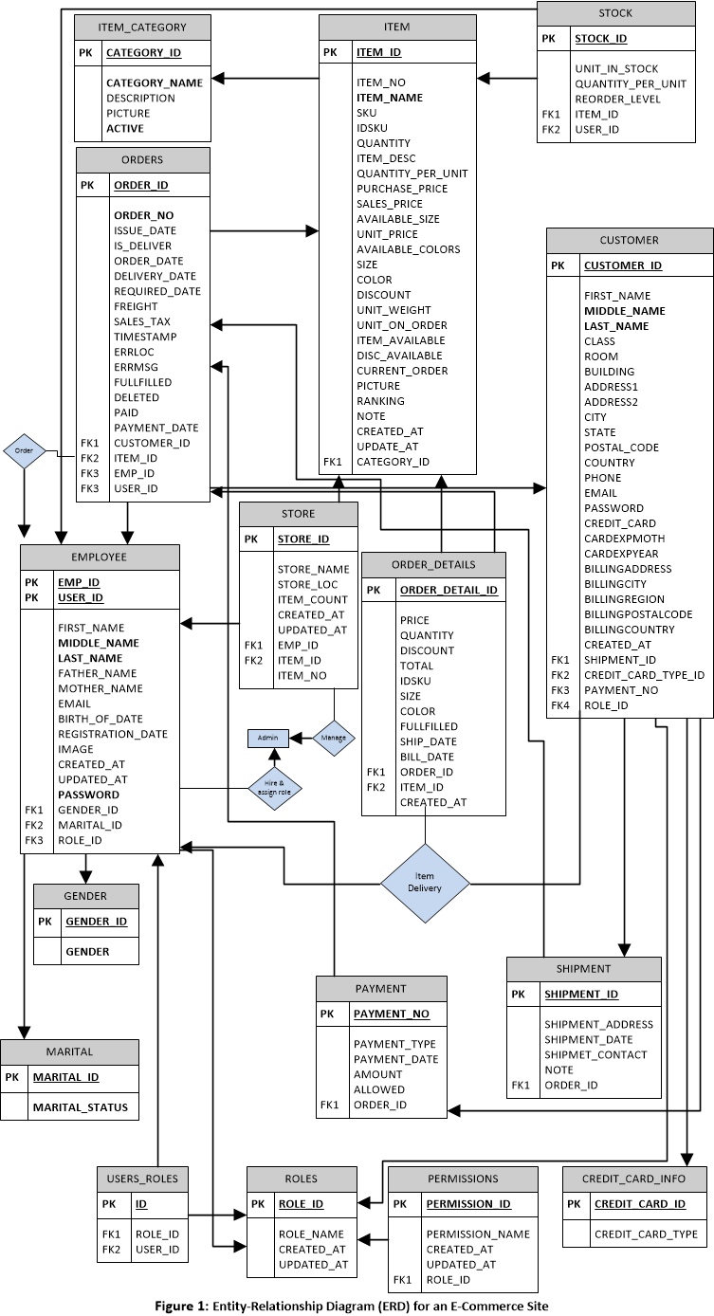

**Submitted the followings:**

1. **ER diagram for the system (Above Figure1)**

* Design a Database System for an E-Commerce Site.

1. **SQL tables converted from the ER diagram**

CREATE DATABASE BUET;

USE BUET;

create table employee

(

emp_id integer not null,

first_name varchar(30),

middle_name varchar(30),

last_name varchar(30),

father_name varchar(30),

mother_name varchar(30),

email varchar(30),

birth_of_date date,

image blob,

user_id integer not null,

created_at datetime,

updated_at datetime,

password char(10),

gender_id integer,

marital_id integer,

role_id integer not null,

primary key(emp_id)

);

create table gender

(

gender_id integer not null,

gender varchar(30) not null,

primary key(gender_id)

);

create table marital

(

marital_id integer not null,

marital_status varchar(30) not null,

primary key(marital_id)

);

create table stock

(

stock_id integer not null,

unit_in_stock integer not null,

quantity_per_unit integer not null,

reorder_level char(10),

item_id integer not null,

user_id integer not null,

primary key(stock_id)

);

create table item_category

(

category_id integer not null,

category_name varchar(30),

description varchar(50),

picture blob,

active char(10),

primary key(category_id)

);

create table payment

(

payment_no integer not null,

payment_type varchar(30),

payment_date date,

amount numeric(10,2),

allowed char(10),

order_id integer,

primary key(payment_no)

);

create table shipment

(

shipment_id integer not null,

shipment_address varchar(100),

shipment_date date,

shipmet_contact varchar(100),

note varchar(100),

order_id integer not null,

primary key(shipment_id)

);

create table credit_card_info

(

credit_card_id integer not null,

credit_card_type varchar(100),

primary key(credit_card_id)

);

create table customer

(

customer_id integer not null,

first_name varchar(30),

middle_name varchar(30),

last_name varchar(30),

class char(10),

building char(10),

address1 varchar(100),

address2 varchar(100),

city varchar(30),

state varchar(30),

postal_code char(10),

country varchar(30),

phone char(10),

email varchar(30),

credit_card varchar(30),

cardexpmoth char(10),

cardexpyear char(10),

billingaddress varchar(100),

billingcity varchar(100),

billingregion varchar(100),

billingpostalcode char(10),

billingcountry varchar(30),

issue_date date,

shipment_id integer,

credit_card_type_id integer,

payment_no integer not null,

role_id integer not null,

primary key(customer_id)

);

create table orders

(

order_id integer not null,

order_no integer not null,

issue_date date,

is_deliver char(10),

delivery_date date,

order_date date,

required_date date,

freight char(10),

sales_tax integer,

timestamp datetime,

errloc char(10),

errmsg varchar(50),

fullfilled char(10),

deleted char(10),

paid char(10),

payment_date date,

customer_id integer,

item_id integer not null,

emp_id integer not null,

user_id integer,

primary key (order_id),

constraint ord_cust_id_fk foreign key(customer_id) references customer(customer_id)

);

create table store

(

store_id integer not null,

store_name varchar(30),

store_loc varchar(50),

item_count integer,

created_at datetime,

updated_at datetime,

item_id integer,

emp_id integer not null,

item_no integer not null,

primary key (store_id)

);

create table item

(

item_id integer not null,

item_no integer not null,

item_name varchar(50),

sku char(10),

idsku char(10),

quantity integer,

item_desc varchar(50),

quantity_per_unit integer,

purchase_price numeric(10,2),

sales_price numeric(10,2),

available_size char(10),

unit_price integer,

available_colors char(10),

size char(10),

color char(10),

discount numeric(10,2),

unit_weight numeric(10,2),

unit_on_order integer,

item_available char(10),

disc_available char(10),

current_order char(10),

picture blob,

ranking char(10),

note varchar(200),

category_id integer,

primary key(item_id)

);

create table order_details

(

order_detail_id integer not null,

price numeric(10,2),

quantity integer,

discount numeric(10,2),

total numeric(10,2),

idsku char(10),

size char(10),

color char(10),

fullfilled char(10),

ship_date date,

bill_date date,

order_id integer,

item_id integer,

created_at datetime,

primary key(order_detail_id)

);

create table users_roles

(

id integer not null,

role_id integer not null,

user_id integer not null,

primary key(id)

);

create table roles

(

role_id integer not null,

role_name varchar(30),

created_at datetime,

updated_at datetime,

primary key(role_id)

);

create table permissions

(

permission_id integer not null,

permission_name varchar(50),

created_at datetime,

updated_at datetime,

role_id integer not null,

primary key(permission_id)

);

1. **Following SQL queries:**
2. **List of customers that place an order with order total for a date range:**

Select a.customer_name, a.total_orders

From

(

Select concat(c.middle_name,' ',c.last_name) as customer_name,count(*) as total_orders

From customer c, orders ord, order_details ors

Where c.customer_id = ord.customer_id

And ord.order_id = ors.order_id

And ord.order_date between '2018-09-01' and '2018-10-30'

) a

group by a.customer_name;

1. **Date-wise order totals for a date range:**

select ord.order_date as order_date, count(*) as total_orders

from orders ord, order_details ors

where ord.order_id = ors.order_id

and ord.order_date between '2018-09-01' and '2018-10-30'

group by ord.order_date;

1. **Item with order total for a date range:**

select a.item_name, a.total_orders

from

(

select i.item_name,count(*) as total_orders

from item i, orders ord, order_details ors

where i.item_id = ord.item_id

and ord.order_id = ors.order_id

and ord.order_date between '2018-09-01' and '2018-10-30'

) a

group by a.item_name;

1. **List of employees with order delivery count:**

select a.employee_name, a.count_delivery

from

(

select concat(e.middle_name,' ',e.last_name) as employee_name,count(*) as count_delivery

from employee e, orders ord

where E.emp_id = ord.emp_id

and upper(ord.is_deliver)='YES'

) a

group by a.employee_name;

1. **Item count in store for all items:**

select i.item_name, count(*) as no_of_items

from item i, store s

where i.item_id = s.item_id

group by i.item_name;